For more information contact:

Chris Kemmer, PR Consultant
CK Marketing & Communications
614-596-3730
chris@ck-marketing-communications.com

or

Janet Dayton, Marketing Communications Manager
Mitchell 1
858-391-5251
Janet.Dayton@mitchell1.com

Mitchell 1 Recognizes Oklahoma State SuperTech Competitor

San Diego, CA (May 11, 2023) – Mitchell 1, a longtime supporter of technician skills competitions, provided a Service Information station at the recent 2023 Oklahoma SuperTech Competition, where TruckSeries software was used to evaluate the proficiency of trucking professionals. Mitchell 1 is pleased to honor the winner of the Service Information Station they administer, Robert (Bobby) Veach, from Bruckners, OK. Veach also won the written test, fasteners and aftertreatment stations and placed 2nd overall in the competition.

“We were honored to sponsor this year’s SuperTech Competition event, and help test the skills of these talented individuals who are key to the success of our industry,” said Kristy LaPage, Director of Mitchell 1’s Commercial Vehicle Group.

Veach was among 24 hand-picked competitors who rotated through a series of hands-on workstations and took a written test.

“We applaud everyone who participated in the event, and are pleased to provide special recognition to Bobby, the top finisher, by awarding him with a gift card,” said Robert Crull, Business Manager of Mitchell 1’s Commercial Vehicle Group. “We look forward to supporting this talented individual as he goes on to represent Oklahoma at the 2023 National TMCSuperTech Competition in Cleveland, Ohio, this fall.”

Mitchell 1 has been a sponsor of the TMCSuperTech national competitions since its inception 18 years ago. The company annually awards the Grand Champion a year subscription to TruckSeries, to recognize the hard work necessary to earn this prestigious achievement.

The TruckSeries software suite provides integrated access to labor estimating, diagnostic trouble code procedures, and repair information for medium- and heavy-duty trucks in a single application. TruckSeries is the only comprehensive truck repair information software suite of its kind available for Class 4-8 trucks, delivering a one-stop, single log-in, all-makes data resource with interactive wiring diagrams, ADAS quick reference, digital pictures, DTC-to-diagnostics, and more, all delivered in seconds.

About Mitchell 1
As a member of the Snap-on® TOTAL SHOP SOLUTIONS brand family, Mitchell 1 has been a leading provider of repair information solutions to the motor vehicle industry for more than 100 years. Mitchell 1 offers a complete line of integrated repair software and services, including vehicle repair information, business management and shop marketing services, to help commercial truck and automotive professionals improve productivity and profitability. For the commercial truck segment, TruckSeries software provides information required to estimate labor times, diagnose and repair all makes of Class 4-8 trucks. For more information, visit the company’s website at mitchell1.com

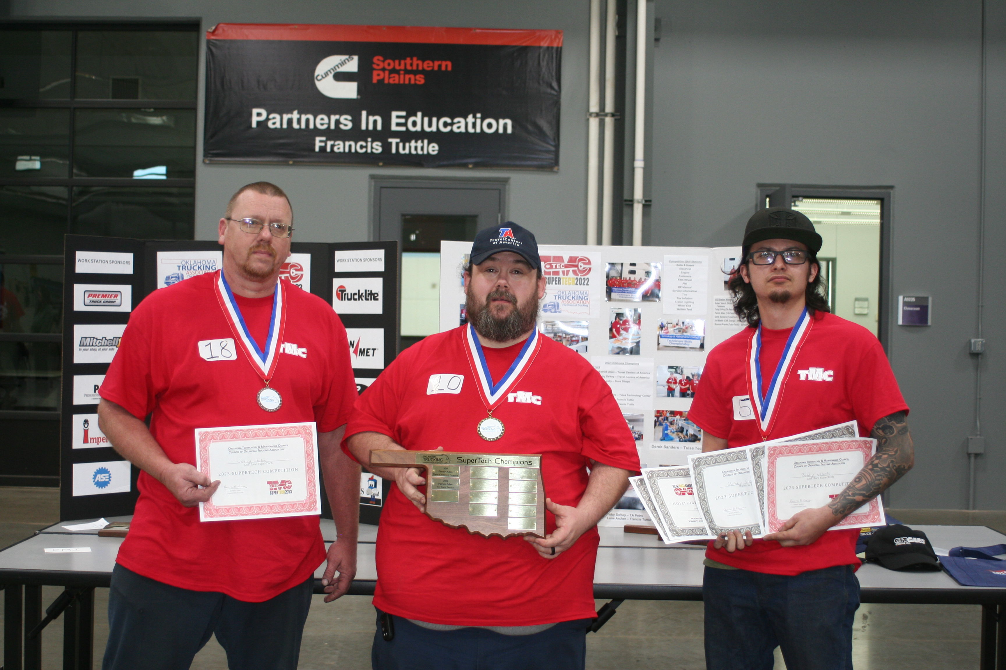
Oklahoma SuperTech Champions 2023
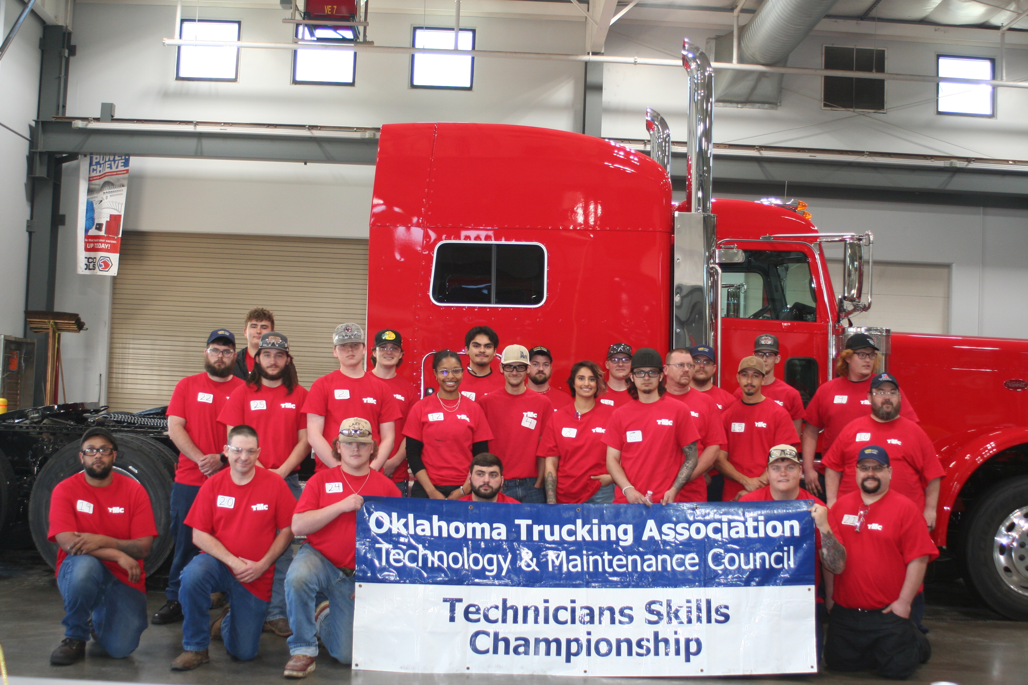
Oklahoma 2023 SuperTech Competitors

